Territory Families
Safe, Respected and Free from Violence
Prevention Fund

Application Form

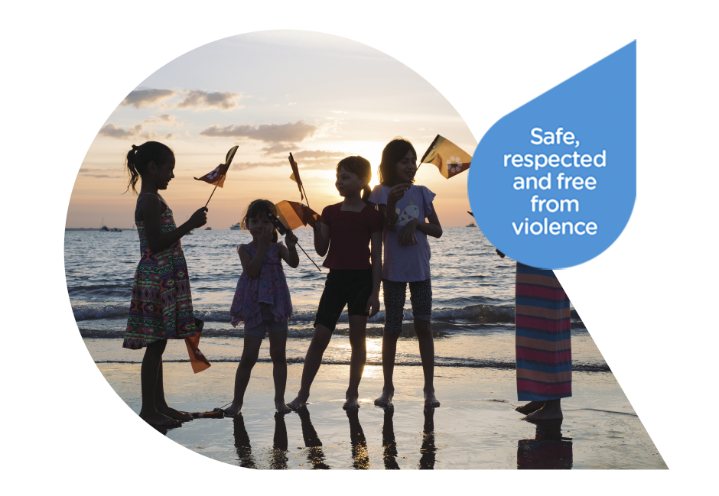

Please read the Safe, Respected and Free from Violence Fund Guidelines before completing your application.

If you have any questions, please contact the Office of Domestic, Family & Sexual Violence Reduction on:
Email: tf.domesticviolencedirectorate@nt.gov.au Phone: (08) 8935 7825

Applicant/ Organisation
Name of Organisation/Auspicing Organisation:
Number of members in organisation:
Contact Person Name and Position Title:
Contact Number:
Email Address:
Postal Address:

Proof of Northern Territory residency or registration as a business or charity in the Northern Territory | NT Drivers Licence Number:
 | NT Business Registration Number:
 | NT Charity Registration Number:

Are you/ is your organisation registered for GST?
Yes |  | No
What is your Australian Business Number:
Public Liability Insurance Cover*
Yes |  | No

Bank Details | Account Name:
 | BSB:
 | Account Number:

Is your organisation/community group incorporated?
Yes |  |  | No
Date of Incorporation:
Details of Sponsoring Body:

* Funding recipients may be required to have, and keep in place, a public liability insurance policy with a recognised insurance provider. Recipients must produce a copy of the policy within 14 days of a request to do so.

About the Funding
How much funding are you requesting?

$
Are you the lead organisation applying in collaboration with other organisation/groups? Please provide confirmation (letter or email) of their support with your application.
Yes |  | No
Please provide details.

Project Details
Title of project:
Date(s) of Project
Location and Venue of project:

Project Information
- Provide a detailed description of the project.
Please give details.
Please provide an outline of the aims and outcomes of the project. How will these be measured?
Are there any similar projects/programs being delivered within the Northern Territory? Please also include any comparable projects/programs being delivered within Australia and internationally.
Please provide a timeline for the project/program.
Please detail how the project/program applies good practice approaches to prevention (see guidelines). Does the project take a primary prevention approach or a secondary prevention (early intervention) approach?
Does your project/program target outcomes for any high risk or specific group? (Please tick all relevant boxes)
 | Children and young people |  | Elderly women
 | Aboriginal and Torres Strait Islander Women |  | Culturally and Linguistically Diverse Women
 | Women with a disability |  | People experiencing mental health issues
 | Elderly women and men |  | People who identify as lesbian, gay, bisexual, transgender, queer, intersex and/or asexual (LGBTQIA+)
 | Other (please specify)
Please give further details as required.
Does your project/program target rural or remote communities? Provide details:

Selection Criteria
Please demonstrate how the project embodies at least five of the seven principles of the Safe, Respected and Free from Violence Framework:
1. Women and children’s wellbeing is at the centre
2. Shared responsibility, partnerships and local responses
3. Evidence and needs-based and outcomes-focused
4. Accessibility, equity and responsiveness
5. A focus on long term social and cultural change
6. Challenging systemic racism and inequality
7. Shared awareness and understanding of domestic, family and sexual violence
Please note: All projects MUST reflect Principles 1 and 3.
Please demonstrate how the project will prevent domestic, family and sexual violence (DFSV) through the following assessment criteria:
The project must satisfy at least three components. Please attach a separate sheet if necessary.
Educates the community about DFSV
Fosters positive personal identities and challenges rigid gender roles, gender inequality, sexism and discrimination
Partners with community, business, sporting and religious leaders to actively reject DFSV
Promotes and normalises gender equality
Encourages protective behaviours and supports children and young people to exercise consent and engage in healthy and respectful relationships.
Develops the capacity of the community to respond to DFSV
What evidence has informed the project design?
Financial Details
Have you applied for or received funding from another funding source for this project? If yes, please provide details below.
Yes |  |  | No
Organisation:
Amount sought/ awarded:
Date funding will be/ was received:
Purpose of funding:
Do you intend to apply for funding from another funding source for this project? If yes, please provide details below.
Yes |  |  | No
Organisation:
Amount sought/ awarded:
Purpose of funding:
Is there a conflict of interest between yourself and a Northern Territory Government employee (personal or family relationship)? If yes, please provide details below.
Yes |  |  | No
Provide a detailed budget on what the funding will be utilised for.
A preferred template is provided below for your use or adaptation. Alternatively you may attach a budget in your own format.
Attached? |  | Yes |  |  | No (using provided)
What kind of commitment/in kind support will your organisation give this project? If collaborating with another party, what kind of commitment will the collaborator/s offer to this project?
e.g. financial, administration, volunteers, catering, transport, promotion and venue/use of facilities

Income
You may insert additional rows or attach a separate budget if necessary
Income | Amount
Other Funding
Grants
Corporate Sponsorship
Fundraising
Other Income
TOTAL INCOME

Expenditure
Please check the guidelines for details of what is eligible for funding and what is not.
Item (please specify) | Total Cost  (GST exclusive) | Your Contribution (in-kind support) | Requested Grant Contribution  (GST exclusive)
Administration Costs
Staff Wages
Consultancy
Case Management Services
Hire Costs
Venue Hire
Equipment Hire
Travel
Transport
Accommodation
Program Resources
Other
TOTAL EXPENDITURE

Promotion
Promotion campaign plan: List how you will promote the project/program, e.g. which advertising medium you plan to use, timeline and anticipated budget.*
 | Provide name of newspaper, magazine, radio station, TV station | Start date of promotion campaign |  | Timeline (how often) | Budget $
Media Release

Free Listing

Paid Print advertisement
Paid Television advertisement
Radio paid advertisement
Direct mail e.g. post, email, newsletter, invitation
Promotional material e.g. posters, flyers, banners
Online (web, social media)
How will your organisation acknowledge grant assistance provided by the Northern Territory Government?
Media advertising |  |  | Banners
Website |  |  | Posters
Tickets |  |  | Program
Other (please specify) |  |  | Printed Materials

*Please note: funding recipients are responsible for promoting and advertising the activity, which must also acknowledge Northern Territory Government sponsorship. Northern Territory Government guidelines are in place outlining the use of logos and the representation of the government on receipt of funding and grants. For further information see the Northern Territory Government Brand Guidelines available at: http://www.territoryremembers.nt.gov.au/sites/default/files/uploads/documents/nt_government_brand_guidelines.pdf

Evaluation
How will your organisation measure the success of the project?
(as part of the acquittal process, all funding recipients are required to provide a written report detailing the results of the funded project).
Successful applicants will need to provide feedback from participants where appropriate.
Statistics
Questionnaires/ Surveys
Interviews
Other (please specify)

Authorisation

- I certify, as an individual/authorised representative of this organisation, that the information given in this application is true and correct.
- I declare that I will ensure the grant funds are acquitted according to the Funding Agreement entered into with the Office of Domestic, Family and Sexual Violence Reduction.
- I have read and understood the Guidelines and Application Form.
- I agree that individuals or organisations mentioned in this application may be contacted as part of the assessment process.
- I understand that information in this application may be provided to other agencies, as appropriate.
- I understand that should this application be successful, some of the information may be used for promotional purposes.

Name:
Position
Organisation:
Signature: |  | Date:

Submitting your application
Checklist - have you:
completed all questions
signed and completed the authorisation
kept a copy of all documentation for your records
attached written confirmation from other organisations/community groups for collaboration and/or the auspicing organisation (if required)
attached a copy of detailed budget plan

Applications should be emailed to tf.domesticviolencedirectorate@nt.gov.au
Alternatively, you may post to:
Office of Domestic, Family and Sexual Violence Reduction
Territory Families
PO Box 37037
Winnellie, NT 0820

If you have any queries, please call Office of Domestic, Family and Sexual Violence Reduction on:
(08) 8935 7825 or email tf.domesticviolencedirectorate@nt.gov.au between 8:00am and 4:00pm, Monday to Friday.

Privacy Notice

Territory Families is collecting the information on this form to ascertain whether or not the application meets the Safe, Respected and Free from Violence Prevention Fund Guidelines and Eligibility. If you do not provide all of the information requested, we may be unable to process your application for funding.

If this application is successful, some of the information may be provided to the Office of the Minister for Territory Families, Territory Families, Media Organisations or Stakeholders for the purpose of promoting your activity.

If at any stage you need to update your contact information, please provide this by email to tf.domesticviolencedirectorate@nt.gov.au.

