Consultation on the Alice Springs Youth Action Plan 2019-2021

  - March 2019

ACKNOWLEDGEMENTS
We acknowledge and pay respects to the traditional custodians of the land where we live; the Arrente people and their Elders past and present and their future leaders. We acknowledge and respect their continuing culture and the contribution they make to the life of Mparntwe/Alice Springs and this region.

INTRODUCTION 4
POLICY CONTEXT: REGIONAL YOUTH SERVICES FRAMEWORK 4
CONTEXT OF YOUTH STRATEGY INITIATIVES IN ALICE SPRINGS 8
Prior Reviews, Policies and Strategy Documents 8
Report to Minister Anderson MLA 2009: Youth Anti-Social Forum - Dec 2008 8
Youth Action Plan 2009-2011 9
Report into the Coordination of Youth Services in Alice Springs 9
Alice Springs Youth Hub: A Discussion Paper – Feb 2011 11
Better Strategies to Respond to Youth Issues in Alice Springs – May 2012 11
Better Strategies Alice Springs Executive Summary - Feb 2015 12
Improving After-Hours Youth Services in Alice Springs Youth Sector Consultation Workshops - May 2017 12
Time to Talk Alice Springs: NT Youth Round Table 2017 13
METHODOLOGY OF THIS CONSULTATION 14
SECTOR CONSULTATION MEETINGS 14
YOUTH SURVEYS 15
SECTOR CONSULTATION TO DEVELOP ACTION STRATEGIES 15
ISSUES IDENTIFIED THROUGH SECTOR CONSULTATION 17
WHAT IS WORKING WELL? 17
ISSUES OF CONCERN 18
Capacity of existing services 18
Cross-organisational integrated case management 19
The most at-risk youth – specific challenges and strategies 19
Support for remote communities 21
Sector professional development 21
Mentoring as a strategy to engage and support young people 22
Education, Training and Employment Pathways 22
ACTION STRATEGIES 23
Build capacity of existing services 23
Improve outcomes for young people in the Youth Justice System 24
Better support for remote communities 24
Mentoring programs for Aboriginal young people 24
Education, Training and Development 25
Integrated programs for young people out late at night 25
Housing that is flexible and responsive to young people’s needs 26
ATTACHMENT A: Youth Questionnaire 27
Youth Questionnaire summary data: 28
ATTACHMENT B: Youth SURVEY 29
Youth Survey summary data 31
ATTACHMENT C: local action group (lag) consultations OCT, NOV AND DEC 2018 35
PARTICIPANTS: lag CONSULTATION ON ACTION STRATEGIES: 1 MARCH 2019 36

INTRODUCTION
This Report documents a series of consultations held in Alice Springs between October 2018 and March 2019.
The purpose of the consultations was to support the development of a Youth Action Plan for the Alice Springs region for 2019-2021. A Youth Action Plan for each region (Darwin, Palmerston; Katherine; Nhulunbuy; Tennant Creek; and Alice Springs) is a key component in the implementation of the Regional Youth Services Framework established by the Northern Territory Government (NTG) in April 2018. The Youth Action Plans are to be developed in collaboration with key community partners, including young people, and outline the goals and priorities for the community over a minimum two-year period. The Regional Youth Services Framework recognises that each of the Northern Territory regions is unique, and allows for differences across the Territory reflecting local needs and priorities.
The consultations were organised and facilitated by the Regional Youth Programs Coordinator in Alice Springs. Participants in the three consultation meetings included representatives of youth service non-government organisations (NGOs), community service NGOs whose clients include young people, employers, employment pathway services, education and training providers, and government representatives from local, Territory and Commonwealth governments. Young people were also consulted through face-to-face surveys in December 2018 and January 2019, conducted with the assistance of Alice Springs youth services and government agencies.

POLICY CONTEXT: REGIONAL YOUTH SERVICES FRAMEWORK
The NTG’s Regional Youth Services Framework (April 2018) (Framework) is a five-year ‘roadmap to support young people to connect, thrive and succeed’. The Framework will help guide Territory Families and other NTG agencies to define, partner, coordinate and collaborate for essential youth services over the next five years.
The aim of the Framework is to get better outcomes for young people through:
- strengthening the involvement of young people and key partners in local decision-making
- guiding the investment of the Regional Youth Services funding
- improving the coordination, connection and planning of local services
- improving the local capacity to better respond to the needs of young people and;
- improving the local monitoring and evaluation of what works through the Regional Youth Programs Coordinators
This Framework aligns with the Territory Families Strategic Plan commitments to:
- support communities and families through targeted investment in early intervention and prevention programs and services
- work with young people and the sector to develop a coordinated and cohesive policy for young people including increasing workforce participation and tackling key issues identified by young people and;
- work with partners to increase youth engagement in education, culture and training
The NTG has, through the Youth Services Framework, committed to:
‘listen to and gather input from all stakeholders, including young people, their families and the community, in the development of our Youth Action Plans to guide our investment. We will consult with our partners across government and non-government to ensure that Territory youth achieve their highest potential. Our funding investment will be transparent and underpinned by local advice and support.’
The impact of this Framework will be measured by the following outcomes:
- increased participation of young people in education, training and employment
- an increase in the resilience and inclusion of young people in the community
- reduction in anti-social and risky behaviour by our young people
- increased community partnerships and collaboration
Based on the Australian Research Alliance for Children and Youth’s (ARACY) The Nest framework, this Framework focuses on the following outcome areas:
- being loved and safe
- having the material basics
- being healthy
- learning
- social and community participation
- positive sense of culture and identity
https://www.aracy.org.au/publications-resources/command/download_file/id/301/filename/The-Nest-Operating-Principles-Priority-Directions-March-2014.pdf

The six operational principles of the Framework determine that the Framework will be:
- needs-based and locally driven
- underpinned by coordination, collaboration and partnership
- driven by young people
- culturally safe and responsive
- evidence-based and youth and family-centred; and
- planned and transparent
The role of the Regional Youth Programs Coordinator in each regional centre is to:
- ensure that this framework is implemented, monitored and regularly reviewed
- support local consultation; local planning and improve the connection and coordination of services for young people

- support building the capacity of local activities and programs (including increased evidenced-based practice); and
- monitor the effectiveness of local activities.
A core responsibility of each Coordinator is to support the development and implementation of the community specific Youth Action Plan which will identify:
- what young people need
- who is responsible for what service or activity
- how these services will be delivered; and
- whether the local responses are making a difference
Regional Youth Program Coordinators will provide coordination and strategic input into the development and implementation of youth programs to maximise collaborative service delivery and limit program duplication.

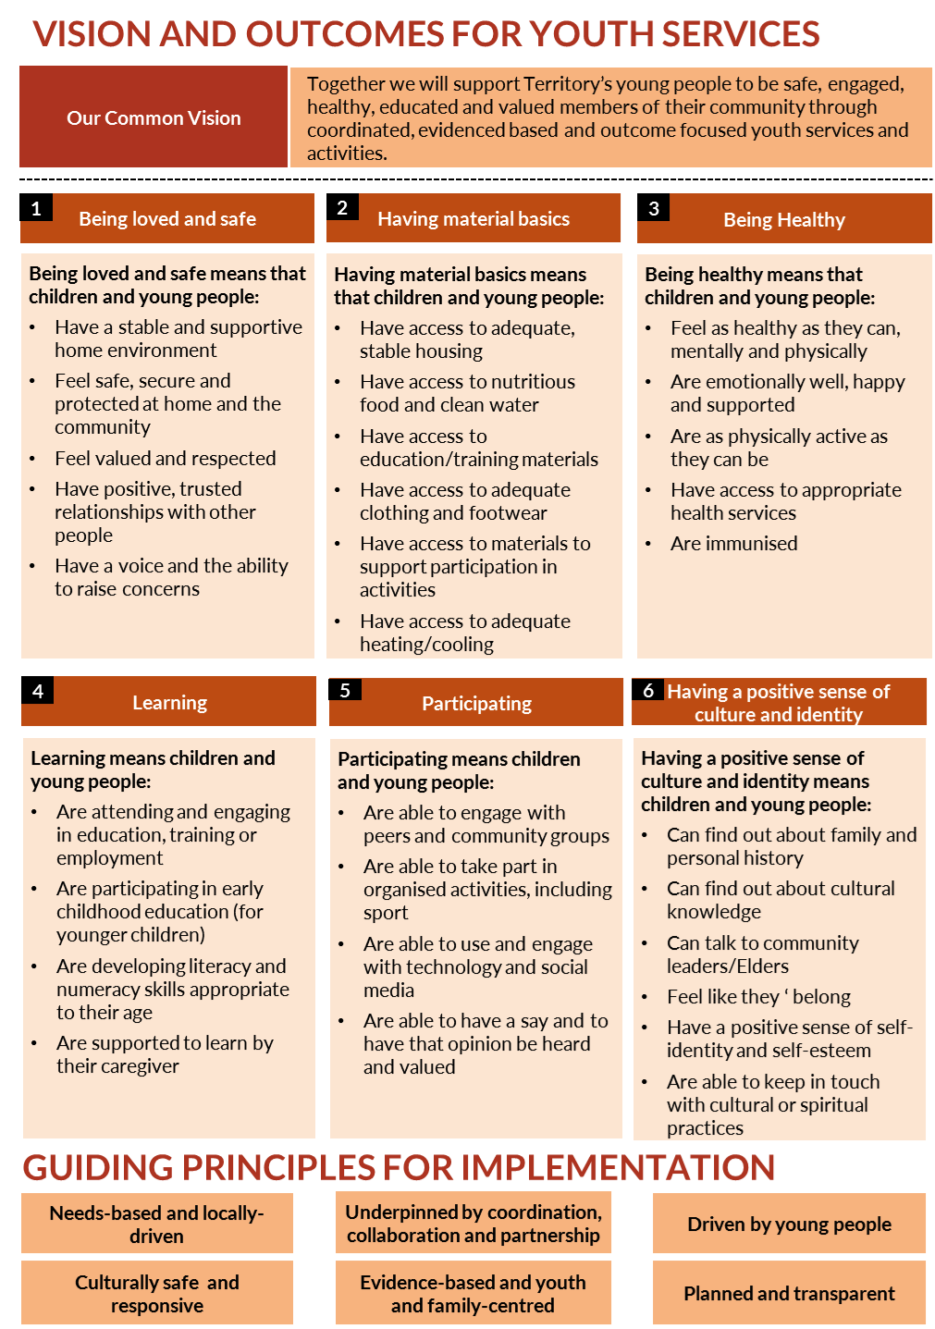
FIG 1: Vision and Outcomes for Youth Services outlines an overview of the vision, specific foci and the guiding principles for implementation of the Regional Youth Services Framework

CONTEXT OF YOUTH STRATEGY INITIATIVES IN ALICE SPRINGS

Prior Reviews, Policies and Strategy Documents
This consultation acknowledges that there has been a long-term, if intermittent, dialogue between the NT Government and the Central Australian youth services and related sectors in relation to youth issues. The key findings of significant consultations by and reports to the NTG from the decade 2009 to 2019 are summarised below.

Report to Minister Anderson MLA 2009: Youth Anti-Social Forum - Dec 2008
In November 2008, the Minister for Central Australia announced that options to deal with youth anti-social behaviour in Alice Springs would be dealt with at a high-level meeting. Key representatives from Commonwealth, Territory and local government attended the facilitated meeting on 9 December 2008.
The forum acknowledged that the complex, multi-layered issues of youth anti-social behaviour cannot be solved in isolation from the broader social disadvantage issues. The forum identified 10 common themes related to solutions to ‘the problems’ associated with youth anti-social behaviour:
- youth services
- family support services
- legal
- accommodation
- community engagement and social inclusion
- interagency cooperation
- alternative/relevant education
- funding
- youth and community safety; and
- evidence based research and collaborative models
Solutions to the problems associated with youth anti-social behaviour were then clustered and refined into five areas.
- Social Inclusion, with 2 categories for action:
  - a Social Inclusion Plan and processes for Central Australia (helicopter view) including establishing a cross-sectoral body, evidence gathering and mapping of services, coordination of sport and recreation services, and measures to improve cultural awareness and Aboriginal engagement.
  - establish Child and Youth Safety Tasking & Coordination Group to provide an inter-agency framework for planning and collaboration between services, and developing engagement strategies for working with disadvantaged youth.
- Parental Responsibility Act and legislative process: to coordinate agencies’ provision of ‘realistic’ support to identified families experiencing significant problems.
- Education: supports for enrolment, identification of government and non-government parties, research into alternative education models.
- Sharing of resources and information: strategies for collaboration, information-sharing and access to resources; development of collaborative and inclusive models of practice.
- Accommodation: safe housing for under 15-year olds, alternative care and respite options, hostel models and boarding school with pastoral care focus.

Youth Action Plan 2009-2011
The NTG implemented the Youth Action Plan 2009-2011 in response to continuing concerns about the number of young people engaged in anti-social activity in Alice Springs, and the number of young people in apparent crisis who were not making effective use of the services available, or for whom no appropriate services were available.
Action Strategies of the Alice Springs Youth Action Plan were:
Education - The creation of a new Alice Springs Middle School operating across two campuses at Anzac Hill and Gillen (Alice Springs High) commencing in 2010. The new middle school will provide students with a wider range of subjects and programs tailored to meet individual needs as well as improved access to resources and support services.
Accommodation - The provision of emergency accommodation and support, including additional safe houses and emergency beds and the establishment of a residential facility for young people who want to attend school but who cannot live at home or independently.
Youth Hub - Establishment of a Youth Hub aimed at making the community safer. The Hub will provide support services and resources to meet individual needs, and help young people stay out of trouble.
Youth Diversion and Patrols - The provision of additional policing and security resources and the expansion of Alice Springs Town Council Ranger Services. Better coordination of transport and recreational services and facilities.

Report into the Coordination of Youth Services in Alice Springs
This report was prepared by David Murray and Tony Kelly on behalf of the NTG in 2009-2010.
To guide the implementation of the 2009-2011 Youth Action Plan, the NTG commissioned a consultancy into the establishment of the Youth Hub and the coordination of youth services in Alice Springs. The consultancy documented in the report delivered, the Alice Springs Youth Action Plan 2009-2011. This was a whole of government approach to getting young people in Alice Springs back to school and/or work and away from crime and other antisocial behaviour activities. While individual agencies were to provide leadership and resources to enable timely and effective interventions, the Youth Action Plan was coordinated by the Alice Springs Youth Action Plan Working Group, with foundational ethics of consensus and evidence-based decision-making, and effective communication and engagement with all stakeholders.
The consultancy identified six key issues:

Coordination of government policy and funding
The consultancy identified a lack of cohesion of government policy and practice, with no clear overview of the youth service system and few mechanisms for policy and funding coordination across and between governments.
Recommended strategies included:
- the establishment of a Youth Policy and Strategy Committee with representatives from the NTG, Commonwealth Government, Alice Springs Town Council and the non-government sector; and
- the development of a youth policy and strategy accord to provide a broad policy and strategic framework for government and non-government services to work collaboratively and to ensure efficient and effective resourcing and service coordination

Coordination of service responses
The consultancy identified perceptions by stakeholders that there was some duplication of effort by service providers; young people were falling through gaps in services and there was a high degree of cooperation on a worker-to-worker level over particular cases.
Recommended strategies included:
- the establishment of the Youth Hub as a youth agency friendly site with physical spaces to be utilised by government and non-government agencies where appropriate
- the clarification of the role of the Youth Services Coordinator in providing leadership in the coordination of government and non-government services; and
- the organisation of the Youth Tasking and Coordination Group as the key coordinating body of the youth services system

After-hours service response
The consultation identified the common scenario that young people observed late at night in and around central Alice Springs often had no safe place to which they could return, leaving the care and protection of vulnerable children and young people in the hands of Police with few crisis response options available. Recommended strategies included:
- the clarification of the powers of Police to place children and young people in emergency and out of home care
- the establishment of a data collection system to more clearly identify the scope and scale of the problem and to provide a structure for ongoing monitoring of the service response to young people; and
- the review and ratification of the Draft Protocol for the Coordination of After-Hours Services

Case management/case work follow-up
The consultation recommended a case management approach to ensure that existing services be harnessed and targeted to the young people most in need, that follow-up be maintained, and that support be given to ensure young people remain engaged in services and programs.
Recommended strategies included:
- the establishment of a referral and case management system that ensured all young people be referred to the appropriate services within 24 hours
- the creation and maintenance of a database of capacity across the youth service system; and
- the development of a protocol for the use and disclosure of private information in accordance with the National Information Privacy Principles

Engagement in school and/or alternative education programs
The problem of significant numbers of young people not attending school on a regular basis was identified as a priority
Recommended strategies included:
- the establishment of a dialogue between youth service providers and education providers to ensure all young people gain access to education programs

Engagement in structured recreational options after hours and in holiday periods.
Linking at-risk children and young people to structured and attractive recreational activities was identified as having the potential to divert young people away from anti-social behaviour.
Recommended strategies included:
- the coordination of current youth recreation programs to ensure better access to existing programs
- consideration of the need for increased resources to upgrade existing recreational facilities and build capacity; and
- the further assessment of the feasibility of increasing access by members of the public to the Alice Springs Youth Centre

Alice Springs Youth Hub: A Discussion Paper – Feb 2011
The discussion paper was an initiative of the Alice Springs Youth Action Plan to guide the consultation process for the establishment of the Alice Springs Youth Hub. The establishment of the Youth Hub at Anzac Hill was an identified Youth Action Plan strategy to provide a focal point for more coordinated services for young people.
The discussion paper identified a shared view on the best way to respond to youth issues in Alice Springs, and generated 12 proposals:
- a single, sustainable calendar of structured activities for young people in Alice Springs all year round
- intensive case management and family support for at-risk young people and their families
- develop smarter ways of ensuring offenders take responsibility for their offending
- build a culture of community service amongst young people in Alice Springs
- improve youth camps by implementing recommendations of the recent evaluation
- improve bail support through close partnerships with the non-government sector
- better strategies to ‘engage’ young people in education and training
- better accommodation options for young people (gaps noted were: lack of crisis accommodation, accommodation for young people with intellectual disabilities and long-term options with or without mentoring support
- increase youth-specific alcohol and drug treatment and long-term rehabilitation
- improve youth-specific health services and programs. There is a need for innovative health programs with a preventative and early intervention focus for young people
- improve public transport. After-hours transport options are critical for young people to provide mobility to return home at night; and
- improve support for ageing carers of young people and supports for young people with challenging behaviours and/or a disability
These 12 proposals formed a robust raft of strategies which were extensively discussed and reviewed in public forums and used as a basis for policy discussion.

Better Strategies to Respond to Youth Issues in Alice Springs – May 2012
In May 2012, the February 2011 discussion paper was updated to reflect changes since 2011. It was noted that the voices of young people who would be impacted by the proposed strategies, in particular young people and Aboriginal community members, had not been captured in the process.
A key area of focus identified for the youth sector was the inherent challenge of working in a cross- cultural environment, and the issue of how Aboriginal young people from urban, remote and town camp communities participate in activities and access public space in Alice Springs. Youth-focused community development programs were identified to bring strong local Aboriginal input into the decision-making process. The youth sector needed to develop meaningful strategies for engaging Aboriginal community members as local consultants, and for engaging in a consistent, face-to-face and respectful consultation with Aboriginal community members.

Better Strategies Alice Springs Executive Summary - Feb 2015
In May 2015 a review of the Better Strategies document provided an executive summary of the changes and current situation.
The summary noted concerning features of the current debate about youth issues in Alice Springs, which seem to remain unchanged being:
- the lack of focus on long-term prevention of crime and anti-social behaviour before it occurs; response to the symptoms but not the cause
- a lack of focus on actively involving young people themselves in identifying problems and developing solutions
- a tendency to talk about young people in isolation from the broader community; and
- a lack of acknowledgement that most people in Alice Springs are not involved in crime or anti-social behaviour
The document notes that the 12 proposals provide a brief overview of how to significantly improve community safety and well-being in Alice Springs; that they are based on research, knowledge and experience in the field; and that a collaborative effort is required. Youth issues should not be relegated to the youth sector, schools or Police in isolation from the rest of the community. Key stakeholders and especially young people need to be involved in strengthening a positive community for everyone.

Improving After-Hours Youth Services in Alice Springs Youth Sector Consultation Workshops - May 2017
Over two days 20 NGOs and government agencies met to explore options for effective after-hours services for young people in Alice Springs. This consultation was in the context of an NTG commitment to improve after-hours youth services.
There was recognition of the extensive consultations and work that had been done in the past, and the intent was to build on this knowledge and the experience of the sector to co-design an approach that would be truly collaborative and meet the needs of young people as well as the community.
Based on shared values, visions, and models, the group worked in cross-organisational groups to develop visions of successful services. At the end of the two days the group collaboratively designed a model for after-hours services which had two parts:
- An overall coordination role, which would coordinate communication (between services, between the sector and government and between the sector and the broader community), set up mechanisms for sharing knowledge and resources (including physical resources such as buses), gather useful data, ensure links with remote communities, manage a brokerage fund for school holiday programs and coordinate advocacy.
- Place based centre/s for young people (not necessarily limited to one venue) which would provide fun, engaging activities, be staffed by trained youth workers, be open at appropriate hours, be accessible, and would be co-designed with young people. The ‘drop-in’ centre/s would be linked to existing services and provide both ways referrals, as well as connecting young people with other existing activities and venues (eg sports, arts, parks, places, events etc)
Both parts would operate as action research processes with built-in mechanisms for evaluation and redesign.
The participants at the workshop expressed a strong commitment to ensuring that the work was collaborative, to ensure it worked for young people and their families, recognising that community safety also includes young people’s safety.

Time to Talk Alice Springs: NT Youth Round Table 2017
Time to Talk (TTT) was a program co-created by two 2017 NT Youth Round Table members following an increased focus on the youth of Alice Springs after a spate of crime in early 2017. TTT sought opinions from a diverse group of young people from across Alice Springs about what they felt needs to be changed in the community.
The major findings were that:
- young people feel there is a negative perception of young people by members of their community
- young people feel they don’t have a voice or a way to express their concerns and that they are not consulted with or listened to when major decisions are made for them; and
- there is a lack of activities and role models for young people
Time to Talk recommended:
- a forum for young people be held to discuss decisions affecting them, and more opportunities for them to express their opinions and thoughts
- more activities for young people throughout the evenings; and
- more youth events and programs to allow young people the opportunity to be positive role models, and to be mentored in a safe and judgment-free environment

METHODOLOGY OF THIS CONSULTATION
The consultation process was led and managed by the NTG’s Regional Youth Programs Coordinator. Centred in Choice was contracted to assist with the documentation of the consultation process.
The consultation encompassed the broadest possible range of service providers related to youth in the Alice Springs region. This included Commonwealth, Territory and local governments, NGOs and services related to youth welfare, law, Police, youth diversion, accommodation, transport, health, mental health, education and training and employment. Representatives from these services formed the Alice Springs Local Action Group (LAG) which became responsible for input into the sector consultation process and the development of the Alice Springs Youth Action Plan.

LAG CONSULTATION MEETINGS
The Regional Youth Programs Coordinator established an extensive email network for communication with the LAG. Email invitations to each consultation meeting were sent to all LAG members.
The Regional Youth Programs Coordinator also invited LAG members to provide written responses about:
- the youth programs that they are responsible for delivering and what successful outcomes they were experiencing within those programs (with the understanding that the definition of `outcome’ can vary within each field of activity)
- ideas about new programs or initiatives which could assist in the delivery of their program; and
- any barriers/gaps that may exist preventing them from being effective in delivering outcomes
Three face-to-face meetings were conducted at the Office of Chief Minister in Alice Springs.
Consultation Meeting | Investment of time | Participation
Consultation 1:  26th October 2018 | 3.5 hrs | 17 participants representing  13 agencies/services
Consultation 2:  16th Nov 2018 | 2.5 hrs | 18 participants representing  14 agencies/services
Consultation 3:  7th December 2018 | 2.5 hrs | 17 participants representing  14 agencies/services

In total, 13 youth sector organisations were represented at the consultation and one local government: Alice Springs Town Council; five NTG Departments: Department of Chief Minister (facilitating the meetings), NT Police, The Department of Infrastructure, Planning and Logisitics - Transport, Territory Families, and the Department of Health; and one Commonwealth department: the Department of Prime Minister and Cabinet (DPMC).
The total number of individual participants who attended the consultations was 30 (several people attended more than one meeting). Organisational representation included local government councillors, government agency program managers, managers of NGO services and programs, and front-line youth services staff.
The consultation discussions focused on:
- the current Regional Youth Services Framework
- lessons from Youth Action Plan in Alice Springs (2009-2011), and the way in which this series of consultation meetings contributes to the Alice Springs Youth Action Plan 2019-2021
- what youth sector services are currently doing well
- key challenges and issues for young people in Central Australia, particularly for those at-risk
- challenges and roadblocks preventing youth services from being effective in delivering outcomes for young people; and
- ideas and strategies for the future: what new programs or initiatives could assist in the delivery of programs
The issues and themes identified through discussion in consultation meeting 1 and consultation meeting 2 were summarised and presented to the third consultation meeting in December 2018, for feedback and elaboration.
The issues identified in this consultation report represent the expressed views of the LAG. Where points were raised and discussed but it was not possible from meeting records to be confident of general agreement by the meeting participants, statements are preceded by ‘Several participants/services …..’. Quotes are used where statements expressed by the participants illustrate points of general agreement.

YOUTH SURVEYS
The Regional Youth Services Coordinator sought direct consultation with young people in Alice Springs. A youth survey developed by DPMC (Attachment A) was endorsed by the LAG for use and conducted through the December 2018 – January 2019 school holiday period with young people, using existing services. Youth workers with established relationships with the participants facilitated the survey process.
A second youth survey (Attachment B) was conducted as part of the Cross-Agency Youth Outreach Response, a joint initiative led by the Department of Chief Minister, NT Police and Territory Families, following growing negative perceptions in the Alice Springs community regarding large numbers of young people frequenting the streets after hours. Surveys were conducted with young people at Anzac Oval by staff from various government agencies and Tangentyere Council Aboriginal Corporation. The summary data is included in Attachment B.

LAG CONSULTATION TO DEVELOP ACTION STRATEGIES
A fourth LAG consultation meeting was held on 1 March 2019.
At this meeting participants were presented with the consultation report of the outcomes of the three LAG consultation meetings, and the results of the Dec 2018- Jan 2019 youth survey.
The purpose of the meeting was to develop action strategies for the Youth Action Plan 2019-2021. The outcomes of this meeting are identified in the PROPOSED ACTIONS section of this consultation report.
A participant list of attendees at all 4 consultation meetings is provided at Attachment C of this consultation report.

ISSUES IDENTIFIED THROUGH SECTOR CONSULTATION

WHAT IS WORKING WELL?
Services remain committed to the principles and strategies developed though earlier consultations and policy frameworks 2009-2019.
All services represented agree that the vast majority of young people in Alice Springs are generally participating in the community in a positive way, attending school regularly, and engaging in pro-social behaviour. They are however subject to multiple stress factors given the significant social, economic and cultural disadvantage which is a pattern of life for many Alice Springs families, particularly Aboriginal young people. In addition, negative public perceptions of young people (as identified in the Time To Talk 2017 report) impact on young people’s self-esteem and sense of social inclusion. These young people require targeted, structured and continuing opportunities and support to engage in social and community life.
The consultation identified a continuing need to focus on young people ‘across the board’, providing a range of services, opportunities and events as a continuous strategy for encouraging positive youth engagement; building relationships between services, young people, and their families; and enabling early identification of needs and issues of concern. This approach allows for early intervention and long-term developmental and therapeutic practice by youth services.
Several services identified a tension or dilemma between this longer-term developmental strategy, and the targeting of resources and services to the needs of young people in crisis who exhibit at-risk, destructive or self-destructive behaviours which attract the attention of Police , children’s services, the media and the public. While diversionary youth services receive targeted fundS specifically to meet the needs of this cohort of at-risk young people, the limitations of funding and capacity were noted (see Issues of Concern section below).
Sector representatives noted many examples of innovative and effective service delivery, and of collaboration across services and agencies:
- Recent school holiday programs have had positive impacts and demonstrate cross-agency and local government collaboration. Examples included the Geek-in-Residence digital media workshops at the public library, and the Splash events at the town pool.
- Services supporting the participation of young people in sporting, music or creative art programs which target young people while also involving the families (eg Drum Atweme, Homemakers program, Yapa Styles).
- Remote communities holding events such as sports carnivals during school holidays to encourage young people to stay at home on community.
- The NTG has set the date of NT Youth Week to coincide with the April school holidays.

ISSUES OF CONCERN

Capacity of existing services
All youth services represented at the consultations are working at full capacity but all see there are unmet needs particularly for the most at-risk cohort of young people.
Services that are successfully attracting at-risk young people are limited in their capacity to respond successfully given structural limitations. Limitations include organisational resources (eg staffing, case management capacity) and limitations of existing facilities (eg available space, impact on other facility users). For example the `Geek in Residence’ program operating in the Alice Springs Town Library has limited space to operate in and consequently some behaviour by young people can impact on other facility users.

Diversion
Diversionary services for young offenders are already working at full capacity, so Police and youth justice services have limited options for referral. Diversion and detention support is limited by a lack of bail options especially for placing young people away from town, and a lack of access to mental health support while in detention.

Mental Health
Child Mental Health Service is working to full capacity and has no capacity to do remote outreach beyond Alice Springs. Central Australia lacks a youth forensic mental health service.

Accommodation
The housing and accommodation options generally in Central Australia are limited. This has particular impact upon Aboriginal residents, leading to severe overcrowding. There is inadequate dedicated youth housing. Alice Springs Youth Accommodation and Support Service (ASYASS) is often at capacity. The Men’s Hostel is always full, and there are no emergency accommodation facilities for women (the Alice Springs Women’s Shelter accommodation is for women and children escaping family and domestic violence). The three month limit on ASYASS supported accommodation is too brief for at-risk young people. There are currently no housing options for young people transitioning out of care. There is no accommodation specifically for young people with mental health problems.

Transport
There are no current transport strategies to get safely home unsupervised young people and children out late at night home in Alice Springs . Public transport – even if free for young people – has limitations, as bus drivers cannot take responsibility for the welfare of young people. Youth services may be able to assist young people to get home safely after events but this requires that the youth services be included in event planning at an early stage.

Aboriginal Mentors
While strong support was expressed for mentoring as a key strategy to engage youth in positive structured activities, in education or employment pathways, and in restorative justice the consultations identified a lack of funded strategies to recruit, train or support Aboriginal mentors. Individual Aboriginal people already employed in the youth sector are placed under pressure to mentor their colleagues in appropriate service delivery, and to mentor at-risk young people.

Cross-organisational integrated case management
Participants affirmed the value of and need for collaboration and information sharing so that youth sector and related services can provide more comprehensive services and support over the whole 24-hour period every day. However, because services are stretched to capacity the opportunities for collaboration are limited.
Representatives of several agencies expressed the view that the formal process of interagency case management meetings is no longer working in a meaningful way, that the process has become over-managed, and that ‘young people are slipping through the cracks’. They argued that the original process of identifying which agency was working with identified at-risk young people, and thereby enabling information-sharing between staff/agencies in private (outside the meetings) has been eroded by the requirement to share confidential information in meetings. Agreement is needed about how organisations share information, in order to maintain or rebuild inter-agency coordination
Several services regretted the ending of the former Department of Children and Families (now Territory Families) Youth Street Outreach Service (YSOS), which worked in collaboration with youth services and Police over the 24-hour cycle. The program provided qualified staff with the statutory authority to respond to children and young people out on the streets at night, to ensure their safety and to organise follow-up case management through the appropriate youth service.
“The YSOS workers could work directly with the kids at-risk, and do referrals so that services could follow up in daytime.“
“Aboriginal YSOS workers could be very effective for out-of-hours engagement with young people at-risk”.
This program required intensive staffing costs and resources for Territory Families. The high cost of this program was acknowledged, but participants also noted the very positive outcomes for many at-risk young people, the reduction in youth crime and anti-social behaviour, and the effective collaborations in case management.

The most at-risk young people – specific challenges and strategies
There is a cohort of approximately 30 disengaged and at-risk 10 to 17 year-old young people with complex needs and challenging behaviours. These young people attract public attention and negative media campaigns for anti-social behaviours. They do not attend school or alternative education systems, or have continual cycles of intermittent attendance followed by suspension/exclusion. Some can no longer be enrolled in schools due to past expulsions or because they are culturally ‘adult’. These most at-risk young people are known to youth services and to Police, and require intensive continuing support from highly trained and resourced services. Participants identified the need for a consistent regional approach to working with young people with challenging behaviour, which includes:
- recognition of the impact of trauma upon child development
- a focus on positive behavioural support
- activities and programs providing small-group structured socialising learning environments
- professional development and support for services and institutions working with young people with challenging behaviour, to support inclusive strategies; and
- recognition that families of young people with behavioural problems often share the same needs and the same experience of trauma, and need similar advocacy and support as there is limited support available for families and caregivers of at-risk young people
Schools appear to have limited capacity, specialist staff or models of practice to address the behavioural problems of disengaged youth who attend intermittently and ‘act out’ in disruptive, destructive and/or self-destructive ways. Consultation participants expressed concern that suspension or exclusion has become a dominant strategy. They expressed the need for greater collaboration between schools and youth services, so that the youth services’ specialist staff could be called in to assist schools to support troubled young people to stay on at school, while also maintaining the safety and welfare of staff and students.
In considering the question of how best to respond to a child (say, a 10 year old) found wandering the streets of Alice Springs at 2.00 am, participants raised several concerns. These include identifying and minimising risk and trying to ensure the safety and welfare of the child; the authority and capacity of the services to act on the child’s behalf; and the need for increased or renewed collaboration between government and services.
Key points raised were:
- children and young people on the streets late at night are not necessarily engaged in anti-social, destructive or illegal behaviour. However, without responsible adult supervision they are vulnerable, at-risk, and can benefit from responsible intervention
“If a child is acting out and escalating the times out at night, it builds a picture and may lead to notification. But this needs clear communication between agencies.”
- children may feel safer on the streets in the middle of the night with their peers or older children/siblings than in their homes. Early intervention can identify and address issues of neglect and lack of safety in the home, but only if immediate response services can engage effectively with the child and their family or make appropriate referrals
- there is a need for expertise available at all hours of the night, with local knowledge of families, of context, and the professional capacity to assess safety
- NT Police has limited capacity and resources to ensure a child’s safety. In an emergency situation Police can take a child to a temporary place of safety, but they have very limited powers in this regard. Police can take a child home but must then find a responsible adult to care for the child, and this can take several hours
- Police can call TF Youth Outreach officers who have the authority to act to find a place of safety and to set up follow-up case management, but only if the child or youth is already known to them (i.e. has existing case management). Youth services could generally find a safe place for emergency placement, if they could be brought into the process; and
- there is a ‘threshold gap’ in the way in which notifications to agencies through SupportLink are flagged and prioritised about children on the streets at night. Consultation participants noted the need for a review of referral mechanisms for children and young people at different levels of risk, so that different follow-up mechanisms can be triggered (eg Police, Child Protection, Intensive Family Support Service and child mental health services). Concerns were expressed about past problems of significant delays in statutory agencies responding to referrals, and whether this signified a lack of capacity, or system problems within SupportLink.

Support for remote communities
Participants noted that poor resourcing of remote Aboriginal communities impacts upon the Alice Springs region.
“We can’t resource town and not remote and expect people to stay out bush. It is important to put resources into supporting good things happening for young people in remote communities”.
Participants were concerned not simply for equity between resources in remote communities compared to Alice Springs, but also for the process of transition for young people between communities and Alice Springs. They wanted to see more flexibility and resources for services to support young people in transition between community and town. For example, Police or youth workers could travel with groups of young people when they come into town for sporting events but would need back-up staffing to prevent stripping vital resources from the community. Similarly, town-based youth services already working to capacity are under-resourced to provide immediate and effective support to young people from communities when they are in Alice Springs, or to assist them to return home to their communities.
Diversion to remote communities for young people on bail or under court-directed diversion orders is likely to be ineffective without support for remote community service providers, and for host families. Police in remote communities have limited capacity to oversee diversion programs. In several cases mentioned, the young people were sent out from Alice Springs without basic bedding or income to host families who were already under financial stress and in overcrowded housing. Communities need to be resourced with skills, not just with funding, and to have improved decision-making and control over diversion placements.

Sector professional development
Several services are now working from trauma-informed practice and therapeutic case management, working to meet the unmet needs of troubled children and young people, and to help them to address behavioural issues. Trauma is inter-generational within many Aboriginal families in Alice Springs. Traumatised young people need long-term support/mentoring to learn to self-regulate their behaviour.
Schools and other public institutions could benefit from professional development in understanding the behavioural impact of the pressures and trauma that many young people experience, and in learning about inclusive strategies to deal with destructive and self-destructive behaviours. School staff have approached youth services for assistance in responding to young people with challenging behaviours, but there are not yet any institutional arrangements for this type of interagency professional development. Youth services noted particular difficulty engaging with non-government schools to support the inclusion of young people with complex needs or challenging behaviours.
Restorative justice (in youth diversion) supports a process for accountability and taking responsibility for one’s actions, consistent with traditional Aboriginal justice systems. There is a need for options within diversion programs for young offenders to make amends, and professional development in a restorative justice model in the youth justice sector could be a strategy to support this.

Mentoring as a strategy to engage and support young people
A need was identified for positive gender-specific Aboriginal mentors. Aboriginal mentors have contributed to successes in youth diversion, mental health, social and emotional well-being and employment services. However this has been limited, ad-hoc and often dependent on Aboriginal staff working beyond their job descriptions. Consultation participants argued for recognition and specific funding for Aboriginal mentors to support and guide service providers and to work directly with at-risk Aboriginal young people, as a productive investment in local skills and knowledge.
Mentoring support was suggested as a strategy to enable the most at-risk students to go to school, remain in school and to participate positively in classes. Consultation participants identified the potential for employment of Aboriginal mentors to support school attendance if funding were available.
There is a need to build the capacity of caregivers in families to mentor at-risk young people. It can be difficult for services to identify and engage on a continuing basis with responsible adults or caregivers who have the trust of the young person, are willing to attend meetings and support their enrolment and participation in education and training, their entry into employment and support to maintain employment, and or their participation in diversion programs.
Mentoring to support young people to engage with structured group or team-based activities can have a very positive impact especially if families become engaged, and the support is consistent and ongoing. This is a potential area for greater volunteer involvement and family involvement in mentoring.
Some participants, however, expressed a concern about a focus on mentoring as a rescue strategy because the youth sector is not able to achieve success in supporting at-risk young people.
“What we need is adequate funding to do the job we are contracted to do.”

Education, Training and Employment Pathways
Current systems to address school non-attendance are poorly resourced. The limited number of truancy (school engagement) officers - currently only three for Alice Springs region - means a limited capacity to follow up on truancy (school engagement) issues in a timely manner.
A significant barrier in the transition to work is the lack of job opportunities for young people in most industry sectors. Some businesses in Alice Springs are currently employing 16-18 year olds without government incentives or support and would benefit from case management or mentoring support through youth services.
Some participants expressed a concern that existing job service agencies are not succeeding for at-risk young people ‘not making the right connections’ and would benefit from working with mentors from the young person’s community and family group.
The administrative processes involved in supporting disadvantaged young people into meaningful employment and training pathways take considerable time and staff attention among all agencies. For example, assisting young people with low levels of literacy in English to gain identity documents, register with Centrelink, complete enrolment forms, set up bank accounts and meet workplace requirements. It was noted that Centrelink is willing to send social work teams out to sites to help young people in these processes of registration, or organisations can become authorised through Centrelink to register young people for income support.
Several youth services stated that they would be willing to provide training and professional development for school staff to enable inclusion and engagement of at-risk students exhibiting disruptive, destructive and or self-destructive behaviour, to make it safe for the young person and for the school.
Schools need greater support in developing pathways into employment and training for disadvantaged and at-risk young people. In particular, consultation participants encouraged the development of vocational pathways that built on Aboriginal cultural knowledge and areas of confidence, eg cultural tourism.

ACTION STRATEGIES
This section documents action strategies developed by participants in the final sector consultation meeting on 1 March 2019.

Build capacity of existing services
Given that all services are currently working to full capacity, government funding levels to services need to be reviewed and strategically increased to support new initiatives and enable services to meet contractual goals.
Infrastructure funding is needed for youth services especially for multi-purpose facilities. Currently there is huge pressure on existing spaces.
Youth services should be involved in the data base development process, for the shared database currently being developed by the NTG. The database should be accessible to youth services so that they have the information needed to collaborate, and to provide effective service to meet the needs of at-risk young people.
Cross-sector training and professional development is needed to ensure NGO and government staff are aware of their capacity and permissions to share information between services. Information sharing rights and responsibilities through Service Level Agreements.
Networking events should be supported and or provided to boost professional development within sector.
Evidence-based evaluation should be built into all funded youth programs.

Improve outcomes for young people in the Youth Justice System
The participants recommended:
- establishing a dedicated Children’s Court, the location of which should not be a big intimidating building, with a dedicated permanent Children’s and Youth Court Judge.
NOTE: A Children’s Court is being established in Alice Springs. This is a part time service. Youth Court Days will be scheduled. Young people still have to go into adult court environment to access the Youth Court
- investigating the Koorie court model, which has a judge and Aboriginal elders as part of the process
- streamlining diversion options for young people especially those living remotely. Streamlining requires:
- NGOs to be brought into the process
- reducing the time lag between offending and consequences; and
- clarifying the services for youth justice and diversion available in the remote communities (eg services provided through regional councils and NT Police).
- funding improved systems for communication and collaboration between remote services and Alice Springs services.

better support for remote communities
Consultation participants identified the need for:
- consistent resourcing across the whole region
- increased brokerage to support youth diversion to remote communities
- an institutional systematic response through NTG youth justice/diversion programs rather than the current process of ad-hoc support; and
- support and resourcing of local Aboriginal leadership and initiatives for youth in remote communities
Additional contributions from 1 March Meeting:
Remote communities and regional councils have very limited funding for activities in remote communities. There is no systematic funding for resourcing youth services across the remote communities. No consistent policy commitment or provision for all communities, currently piecemeal and ad-hoc.
Currently NGOs provide limited service and support as referred by other agencies on ad-hoc basis. CAYLUS has self-funded brokerage to support bail placements (eg travel, food, swag. Anglicare also has small brokerage. JSS has benevolent philanthropic donation small fund.)

mentoring programs for Aboriginal young people

Identified capacity building action strategies related to mentoring include:
- ensuring there is an Aboriginal mentoring component as well as Aboriginal employment targets in funded programs. In particular, specific initiatives and funding are required for Aboriginal mentors to support and guide service providers and to work directly with Aboriginal youth at-risk
- ensuring there is mentoring by young people: youth leadership initiatives and programs should be supported and further developed; and
- evidence-based evaluation needs to be built in to youth mentoring programs

Education, Training and Development
Capacity building action strategies identified for education, training and development include:
- consulting with young people about what they need to help them get to school
- youth services retaining a focus on supporting young people to engage in experiential learning and personal development rather than be directed into vocational training programs
- providing learning opportunities for disengaged young people through the evenings or night.
- clarifying NT Department of Education funding: what is currently being done with Commonwealth funds for alternative and flexible learning provision, and what are the results of evaluations on these provisions
- building collaboration between the youth sector, NT Department of Education and schools to support professional development of staff, and case management support for young people.
- investigating opportunities for family support and mentor support for young people while they are at school
- considering gender issues when developing strategies for re-engaging young men, young women in schools and education pathways and;
- improving access to education and training for young people in detention

integrated programs for young people out late at night
Capacity building action strategies identified for young people out late at night include:
- developing integrated programs to assist young people out late at night to find a safe place and provide support where this is not available
- initiating consultation between Territory Families and the youth sector about how to extend and improve the process of screening and referral
- consultations needing to address the ‘threshold gap’, not just focus on high-risk youth but instead focus on harm prevention, supporting early intervention by the youth services sector for at-risk children and youth
- identifing ‘contextual concerns’ in notifications, and to improve information provided in referrals and or notifications
- accessing timely data - suggested: monthly from Police, Territory Families and Court on youth notifications, referrals, and court and diversion orders
- Territory Families should provide information and data about the screening process following notification by Police or other emergency services, and referral process to family support services and youth services. In particular, information and data are sought about notifications that are screened out (i.e. do not lead to referrals by Territory Families to other agencies); and
- increasing the capacity for self-referral by children and young people to Territory Families.

housing that is flexible and responsive to youth need
Capacity building action strategies identified regarding accommodation include:
- the urgent need for construction and or provision of youth accommodation for emergency, transition into tenancy
- the recognition within youth accommodation services (existing and future improved services) that young people may be recovering from trauma, homelessness, and may not be able to immediately take up school or structured activities and;
- the urgent need for accommodation for young women who are homeless

Additional contributions from 1 March Meeting:
The youth survey and summary data (Attachments B and C) show that 30 percent of participating youth are disengaged from school.
Remote youth services noted that focusing on accredited VET training drives young people away; but providing learning opportunities for young people has strong success. It is important that youth programs remain focused on accessibility, and voluntary participation by young people. Services identified a pressure on youth to channel them into training rather than to deal with their specific problems and needs and support them to address their behaviour and trauma.
There are currently no opportunities for young people under 15 at evening TAFE courses. They could enrol in Alice Outcomes and do their work at Gap Youth Centre (GYC) or other services.
Build on successful strategies for engaging young Aboriginal people, such as the Engawala school model.
Currently, young women who are victims of domestic violence are not eligible to take up ASYASS accommodation.

ATTACHMENT A: Youth Questionnaire
Which of the following things do you worry about: Please tick the appropriate box
Youth physical health | 4 | 10 | 4
Youth mental health | 6 | 6 | 3
Youth sexual health | 9 | 4 | 4
Youth spiritual health | 7 | 4 | 5
Suicide with family and friends | 16 | 2 | 3
Missing out (e.g. from socialising) because of caring for other family | 2 | 8 | 5
Youth disability | 5 | 8 | 4
Ganja and alcohol | 6 | 6 | 7
Gambling | 4 | 7 | 7
Money problems | 5 | 4 | 9
Safety, violence and crime | 10 | 7
Social media and bullying | 12 | 3 | 3
Lack of respect for young people | 15 | 3 | 2
Lack of respect for Aboriginal people | 15 | 2 | 2
Youth support | 10 | 6 | 2
Young people not being cared for properly | 10 | 6 | 2
Going to high school | 9 | 5 | 3
Enough training and development | 6 | 6 | 6
Enough jobs | 4 | 8 | 4
Leaving community | 1 | 13 | 2
Housing | 5 | 9 | 3
Roads | 2 | 11 | 4
Climate change | 1 | 8 | 7
The following questions are designed to get feedback on a range of themes/issues that may or may not affect young people. The red box denotes concern, the yellow box, neither concerned nor not concerned and the green box not concerned. The answers will provide valuable feedback for the development of the Alice Springs Youth Action Plan.
If you could engage young people between the ages of 10-17 over the summer school holidays and return your results to me by Friday 25 January 2019 at: leon.tripp@nt.gov.au or I am happy to pick up the completed questionnaires from your service.

Please circle the appropriate box and provide age:
ATSI: | Non ATSI: | Age: | Gender: F | Gender: M | Gender: Other

Youth Questionnaire summary data:
Twenty one completed questionnaires were returned by the cut-off date from 3 organisations. Some organisations initially responded to the questionnaire by feeling it was too long and some questions too complex for their age cohort.
Out of the 21 participants surveyed, 13 identified as ATSI, 3 identified as non-ATSI and 5 chose no option.
6 males aged 11, 13, 15, 2 x 16 and 17 completed the questionnaire.
11 females, aged 13, 3 x 14, 15, 3 x 16 and 3 x 17 completed the questionnaire.
5 participants stated no age or gender.
The breakdown of the questions and responses are captured in the questionnaire above bearing in mind not all questionnaires were complete with some participants only answering 3 questions.
The greatest areas of concern with 10 or more responses in the red section were as follows:
- Suicide with family and friends - 16 responses
- Lack of respect for Aboriginal people and lack of respect for young people - 15 responses
- Social media and bullying - 12 responses
- Young people not being cared for properly, safety, violence and crime and youth support – 10 responses

ATTACHMENT B: Youth SURVEY
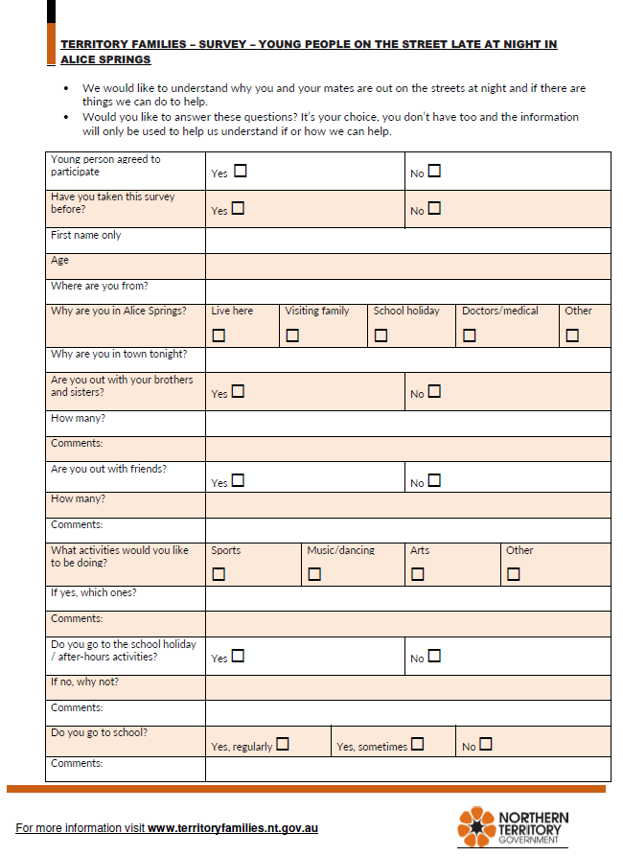
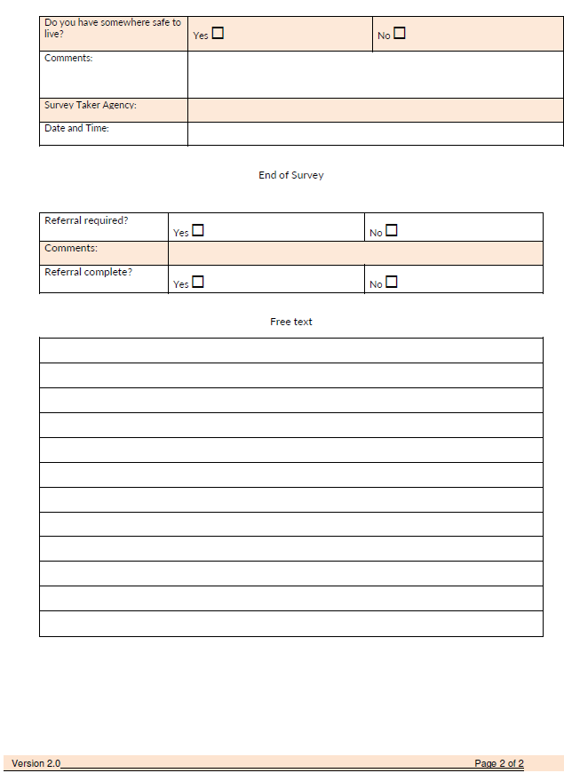

Youth Survey summary data
Surveys were completed with young people on a voluntary basis and information was de-identified and collated into a spreadsheet for analysis. Initial analysis highlights that 115 surveys were completed over the 11 night period, of which 103 unique individuals were identified.
It is important to acknowledge the limitations of the survey data. The risk of duplication data has been minimised by removal of surveys that have identical first names, ages and locations of residence. There is a risk the survey analysis is not a true reflection of young people out at night, as associated with a) not all young people volunteered to complete the survey, b) the response may not have captured the correct cohort or c) young people may have submitted incorrect information.
The below table highlights the age ranges of young people captured in the survey, noting there was no disclosure of any child being under the age of 10 years.

Initial analysis further highlighted 36 young people identified as residing in Alice Springs, with a large portion of young people coming from 24 different communities across the southern region of the Northern Territory. When asked why they were in Alice Springs, 22 young people said they were in for the school holidays and 44 advised they were visiting family.

Young people also shared their views on why they were out at street at night, with over half articulating they wanted to spend time with their family and/or friends. Only four young people disclosed they were at the oval on their own.
Sport was identified as the most popular activity young people would like to engage in, with 67 young people stating they would like to play sport at night. AFL was the preferred option by a lot of the young people, however, there was also requests for soccer, softball and basketball. The second most popular activity identified by young people was playing music and dancing, with 38 young people selecting this option.
In addition, 61 young people stated they attended either an afterhours youth service or a school holiday program with Brown Street Youth Centre, Splash Parties, cinema nights and discos considered the most popular events. Of the 37 young people who stated they didn’t attend these activities, the most common reason provided was that it was boring. Young people also provided their views around school attendance, as reflected in table 4.

A key finding of the survey came from the young people’s perceptions around safety, with the vast majority of young people identifying they had somewhere safe to stay. This was supported by transport provided throughout the outreach response, with the majority of young people identifying a place they could stay. In the small number of instances where a safe place was not identified or a young person disclosed concerns about their safety, referrals were completed to the appropriate agencies.

Comments made by young people also gave rise to the question, do young people share the same perspectives around what is safe? As illustrated by the below extracts from surveys of young people who stated they had somewhere safe to reside:
16 year old: “I stay with Mum, I feel safe, but people drink at her house, so I don’t like to be there at night.”
18 year old: “I stay with family in town, but we stay out to 2am most nights because lots of drunk family at house, wait to they pass out.”
14 year old: “I don’t want to go home to family in Alice until they are all asleep because they are all drunk”.
A general consensus of agencies involved recognised that whilst majority of the young people did not identify as homeless, the reality was that majority were at-risk of homeless due to factors associated with overcrowding, lack of stable and consistent residence, lack of food security, lack of consistent income, prevalence of domestic violence and alcohol misuse.

ATTACHMENT c: lag consultations

PARTICIPANTS: CONSULTATION MEETINGS: OCT, NOV AND DEC 2018
No of mtgs | Organisation | Participant names
2 | Tangentyere Council: Access to Education program  Tangentyere Council: Social Services | Andrew Walder  Maree Corbo
3 | Jesuit Social Services | John Adams
3 | Gap Youth Centre | Michelle Krauer
3 | NAAJA | Derek Denton
1 | Central Australian Youth Link Up Service | Blair McFarland
2 | Central Australian Aboriginal Congress: Youth Outreach, Headspace | Fiona Haddon  Michael Lawton
2 | Relationships Australia | Michael Mitchell
3 | Anglicare: Youth Support Service | Carly Kennedy
1 | Bush Mob | Abraham Kozeluh  Jeffrey Braybon
3 | St Joseph’s Flexible Learning Centre | Sitinder Bahia
3 | Alice Springs Youth Accommodation and Support Service | Tania Warren
1 | Chamber of Commerce | Alana Richardson
1 | Australian Red Cross | Laurencia Grant
1 | Catholic Care | Alanna Aldus
1 | Girls Academy | Rozi Cabone
Government Representation
2 | Alice Springs Town Council | Deputy Mayor Matt Paterson  Councillor Catherine Satour  Jeanette Shepherd
3 | NT Police | Pauline Viicary  Jason Lock  Nicholas Mitchell
2 | Department of Infrastructure, Planning and Logistics, NTG | May Taylor
2 | Department Territory Families, NTG | Sarah-Jane Zaichenko  Reece Dudgeon  Richard Kruger
3 | Central Australian Youth Mental Health, Child Adolescent Health Service, Department of Health, NTG | Sarah McKenzie-Dodds  Bethany Woodward
1 | Department of Prime Minister and Cabinet, Commonwealth Government | Anna Flouris

PARTICIPANTS: lag CONSULTATION ON ACTION STRATEGIES: 1 MARCH 2019

ORGANISATION | REPRESENTATIVE
Gap Youth Centre | Michelle Krauer
NT Police | Pauline Viicary
Jesuit Social Services | John Adams
CREATE Foundation | Elly Jones
Territory Families, YORET | Richard Kruger
Alice Springs Town Council | Jeanette Shepherd
ASYASS | Tania Warren
NAAJA | Derek Denton  James Lowdray
Central Australian Youth Link Up Service | Blair McFarland
Central Australian Aboriginal Congress: Youth Outreach, Headspace | Fiona Haddon
Relationships Australia | Michael Mitchell
Anglicare: Youth Support Service | Carly Kennedy
Tangentyere Council: Access to Education program  Tangentyere Council: Social Services | Andrew Walder  Maree Corbo
Relationships Australia | Michael Mitchell

