Northern Territory Concession Scheme

Frequently Asked Questions

Why are changes being made to the concessions Scheme?

- The current Scheme is inefficient, unfair, outdated and overly complex.

- Some people are receiving very high amounts of concessions on, for example, their electricity bills, and some people are only accessing one or two concessions.

- The administrative complexity of the Scheme has also allowed for fraudulent activity which is unacceptable.

- In addition, Government needs to make sure that the Scheme can remain sustainable in the future so that all Territorians can benefit in their senior years.

- Government wants to keep seniors in the Territory; we recognise that there are many social and economic benefits to seniors staying in the Territory.

- The new Northern Territory Concession Scheme is a $30 million per year investment in senior Territorians and pensioners.

When will the changes happen?

The new Scheme will be implemented commencing 1 January 2018. This doesn’t mean that everything will change on this date, check back on the website for updates about what is happening.

How will I get my concession?

For the time being, you don’t have to do anything; we will tell you if you need to, check back on the website for updates about what is happening.

https://nt.gov.au/community/seniors/nt-pensioner-and-carer-concession-scheme

What will happen now?

There will be no changes until 1 January 2018. We will keep people informed about the changes to the Scheme on the website and through the public consultation.

What will the new Scheme look like?

Territory Families are still working on the details of the new Scheme.

We need to make sure that that new Scheme is accessible for all senior Territorians as well as reducing the administrative processes for Government.

A new Scheme will be introduced commencing on 1 January 2018 which will provide concessional amounts to:

- Pensioners: Territorians who are eligible for certain long-term Centrelink payments including the Age Pension, Disability Support Pension, Carer Payment, Parenting Payment Single and certain Department of Veterans Affairs payments will receive a single concession each year via a debit card.

- Seniors: All Territorians over the age of 65 years who are not eligible for a pension will receive a minimum of $700 every two years via a debit card.

When do I need to use my concession?

Territory Families are still working on the details of the delivery of the new Scheme.

What happens if I don’t use all of my concession during the year?

Territory Families are still working on the details of the delivery of the new Scheme.

What happens if I move away from the Territory?

Territory Families are still working on the details of the delivery of the new Scheme.

However, if you leave the Territory to live somewhere else you will no longer be eligible for Northern Territory Concessions but you may be eligible for concessions in your new home state or territory.

How do I apply for the new Scheme?

Territory Families are still working on the details of the new Scheme with other government agencies.

We will be contacting people that are currently on the Scheme to update their details.

Where can I go to talk to someone about the new Scheme?

For more information on the Northern Territory Concession Scheme call 1800 777 704.

Also, Territory Families have shopfronts in all regional centres. This means you can go in to a Territory Families office and ask for help.

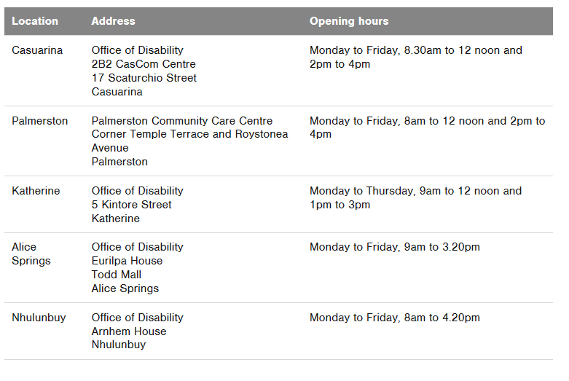
Will I still be able to get $500 back on my travel?

You will be able to use your card at registered businesses, this will most likely include travel agents, we are still working out the details of the businesses where you will be able to use your card but there will be more choices and more flexibility about how you use your concession, and there will be more opportunities to support local Territory businesses.

Will I still be able get free prescription glasses for my dependent child?

You will be able to use your card at registered businesses, this will most likely include optometrists, we are still working out the details of the businesses where you will be able to use your card but there will be more choices and more flexibility about how you use your concession, and there will be more opportunities to support local Territory businesses.

Free bus travel for seniors....

Seniors over the age of 65 will be eligible for free bus travel in Alice Springs and Darwin.
For more details contact the Department of Infrastructure, Planning and Logistics on
(08) 8924 7666 or email public.transport@nt.gov.au

For more information on the Northern Territory Concession Scheme call 1800 777 704.

For information on the Seniors Card call 1800 441 489.

