Territory Families
Safe, Respected and Free from Violence
Prevention Fund

Guidelines
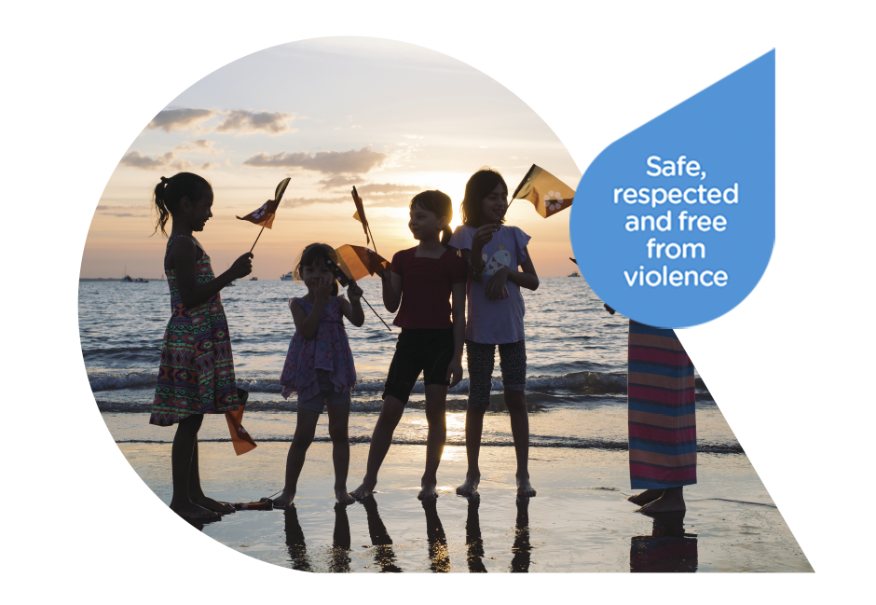

If you have any questions, please contact the Office of Domestic, Family & Sexual Violence Reduction on:
Email: tf.domesticviolencedirectorate@nt.gov.au Phone: (08) 8935 7825

PURPOSE OF THIS DOCUMENT
The purpose of these guidelines is to introduce the Safe, Respected and Free from Violence Prevention Fund (the Fund) and assist you in applying for and acquitting funding.
Please carefully read all sections of these guidelines before applying for funding. If you require assistance with your application or have any queries in relation to the Fund or the funding process please contact our office (details on the previous page).

BACKGROUND
The World Health Organisation (WHO) estimates that 35 per cent of women worldwide have experienced physical and/or sexual violence from an intimate partner. In Australia, this figure is at 16.67 per cent or one in six women. In the Northern Territory in 2015, there were 1 730 victims of domestic and family violence per 100 000 people. This is three times higher than any other jurisdiction in Australia.
Domestic, family and sexual violence is preventable. Good prevention approaches require shared awareness and understanding. Collaborative partnerships that draw on local knowledge and relationships and that challenge the drivers of gendered violence and other intersecting social inequalities can make the most impact.
Our Watch was established under the National Plan to Reduce Violence Against Women and their Children 2010-2022, to drive nationwide change in the culture, behaviours and power imbalances that lead to violence against women and their children. To achieve this they have created Change the Story: A shared framework for the primary prevention of violence against women and their children in Australia and a companion handbook Putting the prevention of violence against women into practice: How to Change the story. In July 2018, Our Watch published ‘Changing the Picture’, a companion document to Change the Story regarding violence prevention in Aboriginal and Torres Strait Islander communities.
There is a strong need in the Northern Territory to improve prevention infrastructure and programs, including community-developed and community-led good practice prevention approaches, to reduce domestic, family and sexual violence (DFSV). Effective primary prevention programs engage the whole population and address the underlying social conditions that perpetuate DFSV. Secondary prevention or ‘early intervention’ strategies target specific groups who are considered ‘at risk’. This program will support both primary and secondary tiers of prevention.
Funding of Prevention Programs
Funding
Source: Change the Story, Our Watch 2015

STRATEGIC OVERVIEW
Launched in December 2017, the Domestic, Family and Sexual Violence Reduction Framework 2018-2028 Safe, Respected and Free from Violence (the Framework) identifies prevention as one of five key outcomes. The Framework will be implemented over the next ten years through a series of three rolling action plans. Action Plan 1: Changing Attitudes, Intervening Earlier and Responding Better 2018-2021 will set out the key actions and initiatives for the first three years, how they will be funded and who will deliver them. The first Action Plan will have a focus on preventing violence including countering gender inequality and the factors and behaviours that reinforce it and recognising that this is a key contributor and driver of violence against women.
The Safe, Respected and Free from Violence Prevention Fund will be an integral component of the Framework’s First Action Plan, seeking to ensure that DFSV is prevented and not tolerated and that respectful relationships and non-violent behaviours are embedded in social consciousness from an early age. The Fund will support community-developed and community-led good practice approaches to preventing violence and supporting children and young people to engage in healthy and respectful relationships, including understanding and exercising consent.

OVERVIEW OF THE FUND
The Safe, Respected and Free from Violence Prevention Fund seeks to support localised projects, including pilot programs, which employ good practice, evidence-based prevention and early intervention strategies essential to preventing violence against women.
Funding for a range of small to medium grants is available for eligible organisations and individuals. The total funding pool for the Safe, Respected and Free from Violence Prevention Fund is $300 000.
Applications which target high risk groups are regarded favourably. High risk groups, as specified in the Domestic, Family and Sexual Violence Reduction Framework 2018-2028 Safe, Respected and Free from Violence, include but are not limited to:
- Children and Young People;
- Aboriginal women;
- Culturally and linguistically diverse women;
- Women with a disability;
- People experiencing mental health issues;
- Elderly women; and
- People who identify as lesbian, gay, bisexual, transgender, queer, intersex and/or asexual (LGBTQIA+).
Applications for programs to be delivered in regional and remote areas are also encouraged.

HOW TO APPLY
The Safe, Respected and Free from Violence Prevention Fund is administered by the Office of Domestic, Family & Sexual Violence Reduction.
Applications must be submitted on an application form provided by the Office of Domestic, Family & Sexual Violence Reduction. Application forms are available online at the Territory Families website www.territoryfamilies.nt.gov.au.
You can request an application form to be sent to you by email or post by contacting the Office of Domestic, Family & Sexual Violence Reduction.
Postal address: PO Box 37037, Winnellie, NT 0820
Office address: Level 6, Darwin Plaza, 41 Smith Street, Darwin NT 0800
Email: tf.domesticviolencedirectorate@nt.gov.au
Phone: 08 8935 7825
The application form is designed to provide information to allow detailed consideration and comparison of applications. Before an application can be considered, all relevant areas of the application must be completed and requested documents attached. Emailed applications are also acceptable, ensuring all required information is provided.

WHO CAN APPLY
To be eligible for funding from the Safe, Respected and Free from Violence Prevention Fund, applicants must:
- be a resident of the Northern Territory with an auspicing organisation; or
- if an organisation, be based and registered in the Northern Territory; and
- demonstrate that the funds will contribute to the prevention of domestic and family violence in the Northern Territory.
The 2018 Safe, Respected and Free from Violence Prevention Fund will open on 1 November 2018 and close on 21 December 2018.

GOOD PRACTICE APPROACHES TO PREVENTION
The development and implementation of primary and secondary prevention programs for domestic and family violence is still a relatively new field. As a result, there is limited research available on the prevention of DFSV. Territory Families is therefore encouraging good practice approaches which draw on the available research base as well as past prevention projects which have been carried out in similar contexts.
Good practice approaches:
- work in partnership (non-government, community-based, government and/or private organisations);
- are inclusive, trauma-based, responsive to diversity and culturally safe;
- support a shared understanding and awareness of what constitutes violence and abuse, particularly within intimate partner relationships;
- adapt to different community, demographic and geographic contexts;
- engage both Aboriginal and non-Aboriginal men to challenge harmful and violence-supportive ideas about masculinity and relationships;
- strengthen positive, equal and respectful relations between and among women and men, girls and boys;
- target young people and promote respectful relationships and the development of a strong identity – including a strong cultural identity and how to deal with conflict;
- include whole of community-led approaches where women, men and young people work together;
- challenge the condoning and normalisation of violence, especially violence against Aboriginal women, by challenging both racist and sexist attitudes and social norms;
- occur in high influence settings such as educational facilities, workplaces and sporting clubs;
- can include projects which have not yet been tested in the Northern Territory but have a compelling rationale and are evidenced by a strong research base; and
- can build on existing initiatives or services but must demonstrate how proposed amendments will improve outcomes for Territorians.
Funding will not be given to projects that:
- are not evidence-based;
- duplicate an existing service or project;
- expand an existing service or projects without making improvements; and/or
- do not sufficiently demonstrate how they will prevent DFSV.

Programs must be tailored to the unique context of the Northern Territory. Aboriginal people in the Northern Territory experience DFSV at vastly disproportionate rates with Aboriginal women 40 times more likely to be hospitalised for DFSV than non-Aboriginal women. This also means that Aboriginal children are disproportionally at a higher risk of exposure to domestic and family violence.
The Aboriginal and Torres Strait Islander People Statement at the 2018 COAG National Summit to Reduce Violence Against Women and their Children called for collaborative partnerships and co-designed, place-based solutions which position Aboriginal communities as critical players.
Programs specifically targeting Aboriginal and Torres Strait Islander groups may also seek to:
- promote self-determination: community ownership, control and leadership;
- acknowledge and address the impacts of colonisation and intergenerational trauma,
- promote healing and recovery approaches which are strengths, community and trauma based;
- reinforce Aboriginal men’s strengths and connections to their family: especially to their children, their children’s mothers and / or partners.
- promote and support Aboriginal women and girls’ participation in leadership roles and decision-making processes;
- facilitate both Aboriginal men and women to be involved in the development and evaluation of prevention and behaviour change programs and initiatives.
DFSV occurs across all segments of the community regardless of culture, age or socio-economic background. Territory Families encourages an inclusive approach to preventing DFSV, taking into account the diverse needs and circumstances of the Territory population. Aboriginal and Torres Strait Islander people should therefore be included in all ‘mainstream’ prevention work and not restricted to programs specifically designed for Aboriginal groups.

SELECTION CRITERIA
Applications for the Safe, Respected and Free from Violence Prevention Fund must demonstrate how they embody at least five of the seven principles:
- Women and children’s wellbeing is at the centre
- Shared responsibility, partnerships and local responses
- Evidence and needs-based and outcomes-focused
- Accessibility, equity and responsiveness
- A focus on long term social and cultural change
- Challenging systemic racism and inequality
- Shared awareness and understanding of domestic, family and sexual violence
Please note: All projects MUST reflect Principles 1 and 3.
Applications will also be assessed against the following criteria and must satisfy at least three components:
- Educates the community about DFSV
- Fosters positive personal identities and challenges rigid gender roles, gender inequality, sexism and discrimination
- Partners with community, business, sporting and religious leaders to actively reject DFSV
- Promotes and normalises gender equality
- Encourages protective behaviours and supports children and young people to exercise consent and engage in healthy and respectful relationships.
- Develops the capacity of the whole community to respond to DFSV
Projects must:
- clearly identify either a primary or secondary prevention approach;
- have identifiable outcomes and project objectives and outline how outcomes and objectives will be measured;
- be part of a comprehensive plan to address need(s) identified by the applying organisation/group/individual;
- not have commercially-oriented objectives or political affiliation; and
- be completed within the time frame proposed unless otherwise agreed.
Applicants must:
- provide all of the information requested including a detailed itemised budget;
- include an outline of the plans for promoting the project;
- demonstrate a need for assistance;
- demonstrate an ability to manage the funds and the project effectively; and
- contribute to the project through funding or 'in kind' support.
Projects must clearly demonstrate how existing evidence has informed the project design.
The Office of Domestic, Family & Sexual Violence Reduction encourages applications from people and organisations across the Northern Territory including remote and regional areas.
Please note: funding is limited and it is likely that the number of applications will exceed the amount of funding available. Due to the competitiveness of the selection process, funding is not guaranteed and should therefore not be anticipated. Furthermore, funding may not cover the total cost of a project.

THIS FUNDING IS NOT ABLE TO SUPPORT
- any project of a political party nature;
- any project of a commercial or business nature;
- set-up or running costs of a business, purchase of capital equipment (including hardware or software);
- retrospective funding for projects, functions, services that have already started or have been completed or items that have already been provided or previously purchased;
- projects by organisations established for profit or financial gain or increased membership;
- projects that duplicate existing services available to the community;
- deficit budgets;
- real estate purchases;
- management or administration fees of the organisation;
- other items that the panel assess as not meeting the aims/objectives of the funding.

ASSESSMENT PROCESS
All applications received are acknowledged in writing from the Office of Domestic, Family & Sexual Violence Reduction. When assessing applications, the following will be taken into account:
- whether the application meets the Selection Criteria;
- program/project innovation;
- identifiable benefits to Northern Territorians;
- level of earned income and the level of support (including in kind) from other sources;
- budget viability and financial management; and
- past performance of the organisation in relation to meeting its aims and objectives.
Applications are assessed by a panel comprised of officers from the Northern Territory Government and may include an independent member from the DFSV/Non-government sector.
All applicants will be advised of the outcome of their application(s) in writing. All decisions are final and there is no appeal process.
Applications may take up to six weeks to process. Please allow for processing time when applying for funding.

CONDITIONS OF FUNDING
Funding recipients must abide by the following conditions:
- Successful applicants, and where appropriate, administering bodies, will be required to sign a Funding Agreement which outlines the purpose(s) of the funding and the conditions under which the funding is provided. Funds will not be provided until the Territory Families Procurement branch has received a completed Funding Agreement.
- Once the Funding Agreement is signed by the funding recipient, successful applicants will be legally obliged to complete the relevant project.
- Applicants will need to carefully budget for their project, as the Office of Domestic, Family & Sexual Violence Reduction will not be held responsible for any applicant who has underestimated the cost of activities related to the project and incurs a loss.
- Funding recipients are responsible for promoting and advertising the project, which must prominently acknowledge the assistance provided by the Northern Territory Government in all media releases and promotional material associated with the funded project with the phrase “Proudly Sponsored by the Northern Territory Government” and the Northern Territory Logo. These marketing materials will be provided to the recipient once the funding has been finalised.
- If the project does not occur within the agreed timeframe as specified in the Funding Agreement, the funds must be returned to the Northern Territory Government. A change or variation to the project may be considered however it must be negotiated with the Office of Domestic, Family & Sexual Violence Reduction in writing prior to the change occurring.
- Funds can only be spent as per the “Purpose(s) of Funding” specified in the Funding Agreement. If a recipient wishes to change the purpose of the project, a written change of purpose request must be lodged with the Office of Domestic, Family & Sexual Violence Reduction. The letter must provide reasons for the change and a budget for the amended purpose. Funds can only be utilised for a new purpose after written approval has been given.
- Any unspent funds are to be returned to the Office of Domestic, Family & Sexual Violence Reduction. Alternatively, the organisation may submit a variation application for a change of purpose to utilise the unspent funds.
- Funding may be subject to tax under the provisions of the Income Tax Assessment Act. Tax is the responsibility of the funding recipient. Funding is GST exclusive.
- If, in the opinion of the Delegated Officer, the funding advanced to an organisation has not been used for the approved purpose(s), or the conditions of funding have not been met, then the organisation receiving the funding will be required to repay the funds in full or in part as determined.
- The Delegated Officer retains the right to vary, cancel or waive any of the conditions and requirements of the funded project.

REPORTING AND FINANCIAL ACCOUNTABILITY REQUIREMENT
On completion of the project, funding recipients must provide a narrative report, financial acquittal report, and copies of any promotional materials, receipts, invoices and photos, to Territory Families within six weeks after the end date of the project. The narrative report must be signed by two office bearers within the organisation to certify that the funds have been expended on the specified funded project, and include a detailed breakdown of all income and expenses relating to the grant.
The narrative report regarding the project should, where possible, contain the following information:
- duration and occasions of service including types of education/description of training or community engagement;
- locations of service;
- approximate number of attendees (including identifying whether the attendees are young people, parents and teachers or other cohorts);
- number of staff delivering the service/project; and
- training and qualification of staff.
The success of the program should, where possible, be measured through pre and post participant feedback (surveys) on:
- what they valued about the education / training / engagement session;
- how it has changed their beliefs or perspectives about the impact of domestic and family violence on women, children, families and the broader community;
- how it improved their knowledge of how to report and respond to domestic, family or sexual violence;
- how it has improved their understanding of gender inequality; and
- the change in their level of confidence and ability to respond appropriately and effectively when a person discloses their experience of domestic, family or sexual violence.

PRIVACY STATEMENT
The information you provide in this application is necessary to determine the suitability of your program/initiative for financial assistance under the Safe, Respected and Free from Violence Prevention Fund. If you do not provide the requested details, the Office of Domestic, Family & Sexual Violence Reduction may not be able to process your application.
By signing the Application Form you consent to your personal information being provided to the Office of the Minister for Territory Families, Territory Families and other agencies for the purpose of promoting and reporting the outcomes of the grant.
Information about successful applications may be publicly released by the Northern Territory Government for the purpose of promoting and reporting on the project. Information may be distributed by:
- media releases issued by the Minister for Territory Families or the Chief Minister of the Northern Territory; and
- promotional material developed by the Office of Domestic, Family & Sexual Violence Reduction and through government websites, including social media.

DUTY OF CARE
Project organisers have a legal and moral obligation to plan properly and take reasonable steps to avoid risks of injury to those persons participating in the project.
If organisers do not plan properly and take reasonable precautions to avoid injury to persons participating in the project, they may be liable to pay compensation to a person who is injured whilst participating in a project organised by them.

INSURANCE
By signing the funding agreement, funding recipients acknowledge that the Northern Territory Government accepts no responsibility for the project, irrespective of the funding provided to support the project.
Funding recipients may be required to have, and keep in place, a public liability insurance policy with a recognised insurance provider. Funding recipients must produce a copy of the policy within 14 days of a request to do so.
If the project involves a public event, funding recipients have a legal and moral obligation to plan properly to avoid risks of injury that might reasonably be expected to occur to patrons and workers at those events.

Our Watch, (2018), Changing the picture: preventing violence against Aboriginal and Torres Strait Islander women.

